City Council offices are located on the 5th floor of City Hall, 915 I Street. To find which council member
represents you and your business, visit https://www.cityofsacramento.org/Mayor-Council/Find-Your-District.
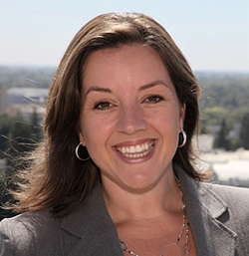
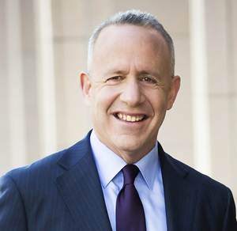

Mayor Darrell Steinberg Vice Mayor Eric Guerra | District 6 Angelique Ashby | District 1
Phone: (916) 808-7000 Phone: (916) 808-7006 Phone: (916) 808-7001
Email Mayor Steinberg Email Vice Mayor Guerra Email Councilmember Ashby

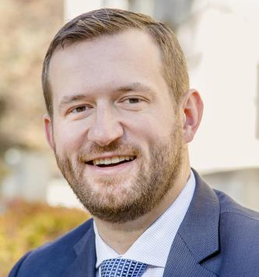
Allen Warren | District 2 Jeff Harris | District 3 Steve Hansen | District 4
Phone: (916) 808-7002 Phone: (916) 808-7003 Phone: (916) 808-7004
Email Councilmember Warren Email Councilmember Harris Email Councilmember Hansen

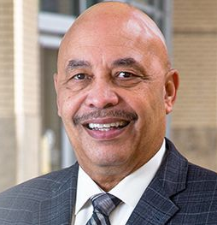
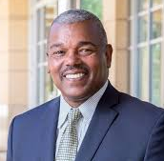
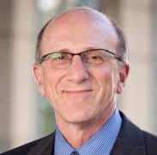
Jay Schenirer | District 5 Rick Jennings, II | District 7 Larry Carr | District 8
Phone: (916) 808-7005 Phone: (916) 808-7007 Phone: (916) 808-7008
Email Councilmember Schenirer Email Councilmember Jennings Email Councilmember Carr

Howard Chan | City Manager
Phone: (916) 808-7488
Email City Manager Chan

